`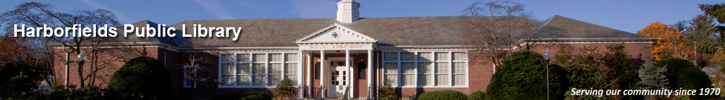

Global Viewpoints Forum

Core Beliefs and Values -
Why Do We See The World The Way We Do?

Harborfields Public Library – Zoom Video – February 9, 2021
Facilitator: John Busch
Core Beliefs and Values – Why Do We See The World The Way We Do?

Relevant Data: (Wikipedia, Psychology Today, Cmu.Edu, Forbes, Nps.gov, NYT, Usc.Edu, Scientific American)

Background

Definitions and Examples: (Core Beliefs and Values help determine why we see the world the way we do)

- Core Beliefs – Beliefs we hold to be true - Very essence of how we see ourselves, other people, the world, and the future – Things we hold to be absolute truths deep down, underneath all “surface” thoughts – Firmly embedded in our thinking and significantly shape our reality and behaviors – Nothing matters more than core beliefs – How we interpret life experiences
- Examples – I am good / bad – I am smart / not smart – The world is fair / not fair - I will / will not succeed – People are good / bad – There is / is not a way – Failure is / bad / a learning tool – People like / don’t like me – I can / can’t trust others – World is a beautiful / dangerous place
- Core Values– Fundamental beliefs – Define you as a person – Define what matters to you as an individual – Determine degree of importance of things or actions – Determine what actions are best
- Examples – Friendship – Achievement – Dependability – Reliability - Justice – Determination – Faith – Honor – Courage – Compassion – Adventure – Integrity – Ethics – Commitment – Trust – Hope – Optimism – Positivity – Commitment – Compassion - Curiosity
- Conscious and Sub-Conscious - We are often unaware of our Core Beliefs and Values, and therefore don’t see how they may impact our views of others and the world – Beliefs and Values can overlap
- Where They Come From – Formed early in childhood – Family – Friends – Peers - Religion – Influencers - Culture - Media – Life Experiences – Observations - School - Reading
- Foundation of Misunderstandings/Disagreements – “I don’t understand why you can’t see the obvious correctness of my position.” – Why otherwise similar people can “see” the same “facts” differently

Illustrative Example:
- Reasonable Opportunity – “Every child should have a reasonable opportunity to achieve a life of happiness, dignity and self-respect” – Our individual Core Belief and Value understanding of what constitutes “reasonable” and “opportunity” will influence how we see and judge an individual’s actions – Does a poor minority child have same / less opportunity, or should / shouldn’t get second chances

Holding Contradictory Views:
- Walt Whitman Blades of Grass 1892 – “Do I contradict myself? Very well then, I contradict myself. I am large and I contain multitudes.” – Core Beliefs and Values are very strongly held, but can be flexible - Humans are extraordinarily complex beings who can – comfortably – hold conflicting views on major issues, and often do not recognize nor care about the conflicts
- Examples – Against capital punishment, except in some cases – Lying is always wrong, except sometimes - I always do the right thing, except not always - I am against “X”, except in some cases - Everyone has the same opportunity to exceed, except, perhaps not everyone

Core Beliefs and Valuers – Why Do We See The World The Way We Do?

Discussion Questions:

. . . Core Beliefs and Values . . .

- How aware are we of our own Core Beliefs and Values, and how they may impact how we see the world?

- Do we share fewer Core Beliefs and Values than in the past, and if so, why?

- Do differences in Core Beliefs and Values help explain our current political, cultural, and societal divisions?

- Can we change our Core Beliefs and Values?

Next Forum – March 9, 2021
Topic: Top 10 Geopolitical Risks for 2021 – What Are They, and What Can Be Done?

Suggestions for Future Topics?
Email me at: johnabusch@aol.com, or call me on: 516 380 1381

